
云南大学软件学院期末课程报告
Final Course Report
School of Software, Yunnan University

个人成绩
学号 | 姓名 | 专业 | 成绩
20243120101 | Hassan  Muhammad | Artificial  Intelligence

学 期：3rd Semester
课程名称: Professional Training -YN3012170034
任课教师: Professor Ahmad Zahir
题目: Containerized NLP System for Text Summarization and Semantic Search
联系电话: 18725100020
电子邮件: hassaanbalouch92@gmail.com
报告完成时间： 2025 年 12 月 18 日

Containerized NLP System for Text Summarization and Semantic Search

Author: Hassan Muhammad
Yunnan University

Abstract:
There is too much digital text that we create. It is impossible to read everything manually. Automated tools are in high demand because they can summarize documents and search content based on meaning rather than simple keyword matching. This project introduces the design and realization of a full machine learning application that addresses this issue.
I created a system and conducted Abstractive Text Summarization and Semantic Search. I employed a microservices architecture with the help of Docker. The system relies on the model of DistilBART transformer to compose summaries in a brief form. It involves the MiniLM model to convert the text into mathematical vectors. These vectors were stored using ChromaDB. This allows the system to retain previously processed information.
I developed the user interface using Gradio (port 9000) and the backend using Fast API (port 9001). In this report, I have recorded the process of constructing the system. It includes the way I chose the models and how I resolved technical deployment problems, such as memory crashes and network timeouts with Aliyun mirrors. The end product is the available AI application that is user-friendly in installation and use.
Keywords: Natural Language Processing (NLP), Machine Learning, Docker, Microservices, Abstractive Summarization, Semantic search, Vector Database, Transformers, ChromaDB, FastAPI, Gradio.

GitHub: https://github.com/hassaandanii/ai_chatbot_summanizer.git

Table of Contents
1. Introduction
1.1 Background
1.2 Project Statement
1.3 Project Objectives
2. Literature Review
2.1 Transformers and Summarization
2.2 Embeddings and Semantic Search.
2.3 Comparison of Tools: ChromaDB and FAISS.
2.4 Comparison of Frameworks Hugging Face and LangChain.
3. System Design
3.1 Architecture Overview
3.2 The Data Pipeline
3.3 Docker Setup
3.4 API Specification
4. Implementation
4.1 Backend Logic
4.2 Frontend Interface
4.3 Database Integration
4.4 Docker Implementation (Mirrors & Ports)
5. Results and Evaluation
5.1 System Startup
5.2 Summarization Quality
5.3 Vector Persistence
5.4 Performance Metrics
6. Discussion
6.1 Challenges
6.2 Benefits of Containers
7. Conclusion And Future Work
7.1 Conclusion
7.2 Future Work
8. References

1. Introduction

1.1 Background
We are drowning in data. The news articles, reports, and emails are numerous and come faster than we can read. We require something to be able to take out the key points of a document within a short period of time. We also have to seek information not only with matching keywords but also based on what it means. Simple statistics were used to count words in the old methods. Such approaches did not always get to the point of the text. Deep Learning changed this. In particular, the Transformer model invention enabled computers to interpret the context in a much better way.

1.2 Problem Statement
On a laptop, an AI model can be easily run in a test environment. The implementation of that model is far more difficult as an actual application. This has been referred to as the deployment gap. Models tend to break due to a conflict of the software types. Computer memory is also consumed heavily by them. In case of failure to do this properly, the application will crash. I aimed at addressing these issues with the help of containers.

1.3 Project Objectives
Its primary objectives were to create an NLP application that is deployment-ready. My specific objectives were:
- Build an NLP Pipeline: Create a system that summarizes text and generates search vectors.
- Add Storage: Add a Vector Database (ChromaDB) to store the history.
- Use Containers: Use Docker to package the app into isolated services.
- Create a UI: Design a minimal web interface such that anyone can use it.

2. Literature Review

2.1 Transformers and Summarization
Transformers and Summarization in 2017, Google published an article known as Attention Is All You Need. This brought about the Transformer. Before this, the computer read a text word by word until the end. Transformers process the entire sentence at once rather than word by word. This is to assist them in learning the correlation between words.
To summarize, I referred to three primary models:
- GPT: Creative writer, but a fabricator. This does not augur well with reasonable summaries.
- BERT: Excellent at reading, but lacks the ability to compose new sentences.
- BART: This model is similar to a translator. It reads text and rewrites it.
My Choice: I have chosen DistilBART. It is a smaller size of BART. It is significantly faster and consumes less memory. This was an optimum selection of running within a container within a laptop.

2.2 Embeddings and Semantic Search
Semantic search is searching through meanings. When I query dog, I would like to have puppy as well. To do this, I use Embeddings. An embedding model converts a sentence to a sequence of numbers. Sentences that have similar meanings are assigned similar numbers. This similarity is estimated on the basis of "Cosine Similarity," which is the angle between two vectors. I used the MiniLM model. It generates a 384-dimensional vector. It is very fast and efficient.

2.3 Tools Comparison: ChromaDB vs. FAISS
I had to have a means of storing these vectors.
- FAISS: It is a Facebook library. It is extremely fast. However, it is just a library. To handle the files yourself, you need to write a lot of code to handle them. It is not good at working with text metadata.
- ChromaDB is a complete database server. It deals with the vectors and the text. It works very well on a Docker container.
My Choice: I chose ChromaDB. Its client-server structure is suitable to the microservice architecture of my project.

2.4 Comparison of Frameworks Hugging Face and LangChain.

- LangChain: This program is a framework that links various AI tools. It is trendy, yet there is an abundance of intricacy. It can be hard to debug.
- Hugging Face: It is a library that provides direct access to the models.
- My Selection: I went directly to Hugging Face. My pipeline is direct. I did not require the additional stress of LangChain.
My Choice: I used Hugging Face directly. My pipeline is straightforward. I did not need the extra complexity of LangChain.

3. System Design

3.1 Architecture Overview
I applied a Microservices Architecture. This divides the app into three different sections. When one of them fails, the others remain intact.
- Frontend: UI thin web server (Port 9000).
- Backend: Backend is a worker that executes the heavy AI models (Port 9001).
- Database: A storage service of the vectors (Internal Port 8000).

3.2 The Data Pipeline
- The following steps occur after the user enters text:
- Ingestion: The backend receives the text.
- Cleaning: Unnecessary whitespace is removed.
- Summary: The text is taken through the DistilBART model. The model creates an overview.
- Vectorization: The text goes through the MiniLM model. This creates a list of 384 numbers.
- Storage: The text and the summary as well as the numbers are forwarded to ChromaDB.

3.3 Docker Setup
I managed the system with the help of Docker Compose.
- Networking: I developed a bridge network. This enables the containers to communicate with each other with names such as http://backend rather than the IP addresses.
- Volumes: I had 2 persistent storage volumes.
- huggingface_cache: This is used to save the AI models. It prevents 1.5GB of files that have to be downloaded each time the system restarts.
- chroma_data: This is the database saved. This is to guarantee that history is not lost when the computer is switched off.

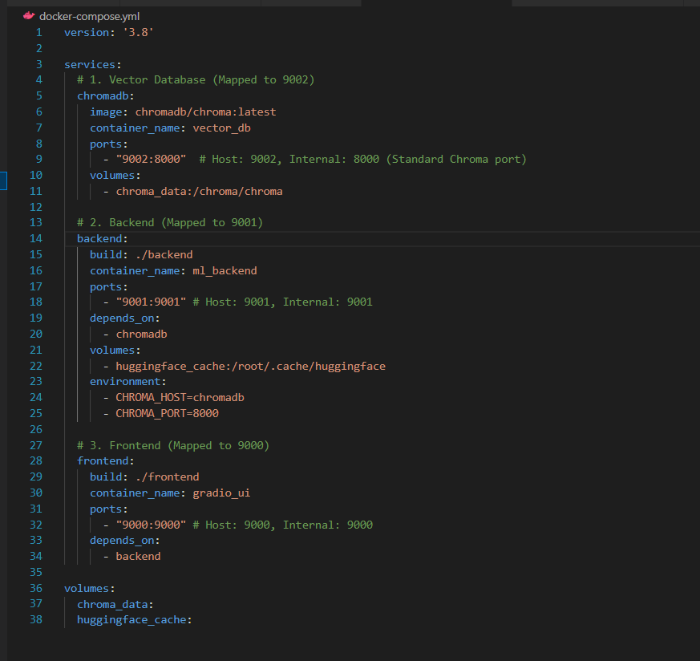

3.4 API Specification
In order to explain the way in which the frontend and the backend interact, I created a particular structure of the JSON.
Request URL: POST /summarize.
Upon clicking the summarize button, the request is sent from the frontend to the backend.
Response Payload:
The data is processed by the backend, and the next structure is provided.
Such a clean separation implies that I would easily switch the frontend design in the future without interrupting the backend logic.

4. Implementation

4.1 Backend Logic
I built the backend using FastAPI. It is fast and handles data validation automatically.
Global Model Loading:
I developed the back-end with Fast API. Global Model Loading: Loading AI models takes time. To load the models, I created the code in main.py to run only one time when the server is started. The models are not reloaded for each request.
Handling Large Vectors: The implementation of one of the details is in the /history endpoint. The vectors (embeddings) are too huge to transfer to the web browser. I inserted logic to remove the field of embeddings and proceed with the rerouting of the JSON response.
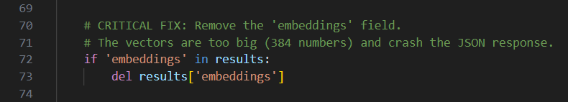

4.2 Frontend Interface
I have used Gradio as the interface. It enables me to create a web page with the help of Python only. The frontend is connected to the backend by the internal Docker DNS name of the backend:9001. I made two tabs, one was called Summarizer, which served as the primary task, and the other was called Database History to see the data that was saved.

4.3 Database Integration

The backend will be connected to ChromaDB via an HTTP client. It has a host that is being sought as chromadb on port 8000. I established a collection called the summary history. This serves as a sorting box of all the processed documents.

4.4 Docker Challenges
I have created tailor-made Dockerfiles of the services. I applied python:3.9-slim so that the image sizes remain small.
The Aliyun Mirror Fix:
I also encountered a huge problem of the speed of the internet. Getting libraries through the conventional servers was very slow and led to the failure of the build. I edited the Dockerfiles to contain the Aliyun mirror.
Dependency Pinning:
The frontend/requirements.txt also had to be edited by me to resolve a crash. The gradio library was in conflict with huggingface.hub. To fix this I had to pin the version to 0.25.0

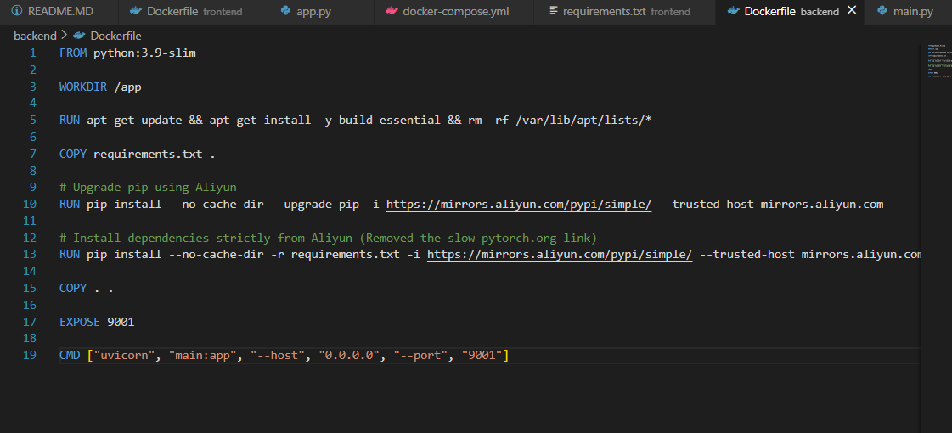

5. Results and Evaluation

5.1 System Startup
I put the system on the docker-compose up --build. The initial download was slow in order to download the 1.5GB of model data. The duration of starting was less than 30 seconds. The logs showed that Uvicorn was working at port 9001.

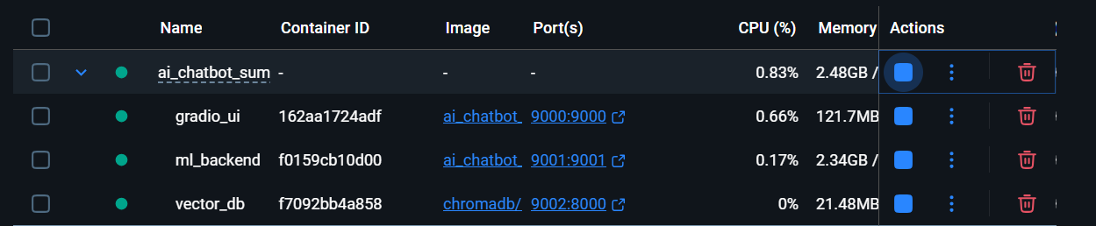

5.2 Summarization Quality
The DistilBART model worked fine.
- Test: I keyed in a 400-word journal article about the history of Football.
- Result: The model gave out a 70 word summary. It was correct in highlighting the history of Rugby and Association Football during the 19th century and their differences.
- Analysis: The analysis has been carried out on new sentences rather than copying text. This shows that this is an abstractive summary of the model.
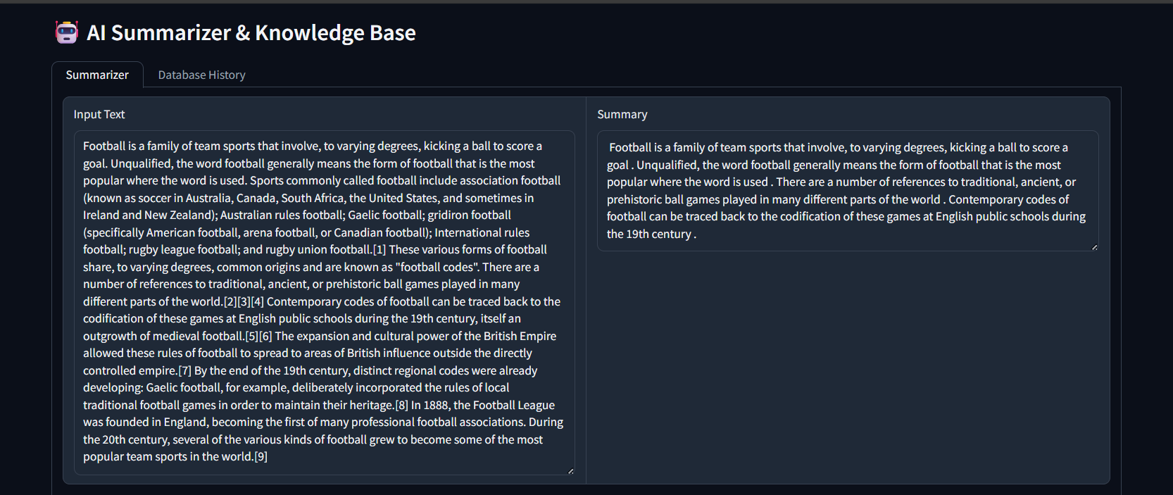

5.3 Vector Persistence
I tested whether the database recalls data.
1. I summarized five articles.
2. I stopped the Docker containers.
3. I restarted them.
4. I selected the Database History tab. The five records still remained.

5.4 Performance Metrics
- Memory: The memory consumed approximately 1.8GB of RAM by the backend container.
- Speed: It takes me approximately 3.5 seconds to summarize using my CPU. Vector generation requires less than 0.2 seconds. This is well acceptable to a local application.

6. Discussion

6.1 Challenges

Memory Crash
Memory was the greatest issue. The container crashed without sending any error message (Exit Code 137) when the backend attempted to load the models. As it turned out, Docker on Windows allocates only 2GB of RAM by default. This was not enough. I needed to make a .wslconfig file that makes Windows allocate Docker 4GB of RAM.

Network Timeout:
Install commands of standard pipes continued to fail with connection timeouts. This was resolved as soon as the Aliyun mirror was switched to in the Dockerfile.

Port Conflicts
My initial attempt was to use ports 8000 and 7860; however, these ports were busy on my machine. I refrained from using the same backend and frontend by using frontend 9000 and backend 9001.

6.2 Benefits of Containers
Docker solved the software conflict issues. The database needs specific system tools. The AI models need specific Python libraries. If I installed all of this directly on my laptop, they would conflict. Containers keep them isolated and stable.

7. Conclusion And Future Work

7.1 Conclusion
This project successfully achieved its objectives. I created an entire machine learning pipeline. It includes the process of choosing a model to implement it in a production-like setting. This project showed that infrastructure is as important as the code itself. The complex aspect of AI engineering is the control of memory, networks, and dependencies. I was able to cope with this complexity with the help of the microservices architecture.

7.2 Future Work
The system works well, but I could improve it:
- GPU Support: It is currently working on the CPU. It would take almost no time to utilize a graphics card (CUDA).
- RAG (Retrieval Augmented Generation): The vectors are stored there, but not in answers. I might include a section in which users will seek answers to questions concerning the articles they summarized.
- Authentication: At this point, they all appear to have identical history. I should add a login system

8. References

- Vaswani, A., Shazeer, N., Parmar, N., Uszkoreit, J., Jones, L., Gomez, A. N., ... & Polosukhin, I. (2017). Attention is all you need. Advances in neural information processing systems, 30.
- Devlin, J., Chang, M. W., Lee, K., & Toutanova, K. (2018). BERT: Pre-training of deep bidirectional transformers for language understanding. arXiv preprint arXiv:1810.04805.
Link: https://arxiv.org/abs/1810.04805
- Lewis, M., Liu, Y., Goyal, N., Ghazvininejad, M., Mohamed, A., Levy, O., ... & Zettlemoyer, L. (2019). BART: Denoising Sequence-to-Sequence Pre-training for Natural Language Generation, Translation, and Comprehension.
Link: https://arxiv.org/abs/1910.13461
- Reimers, N., & Gurevych, I. (2019). Sentence-BERT: Sentence embeddings using Siamese BERT-networks. arXiv preprint arXiv:1908.10084.
Link: https://arxiv.org/abs/1908.10084
- Sanh, V., Debut, L., Chaumond, J., & Wolf, T. (2019). DistilBERT, a distilled version of BERT: smaller, faster, cheaper and lighter. arXiv preprint arXiv:1910.01108.
Link: https://arxiv.org/abs/1910.01108
- Johnson, J., Douze, M., & Jégou, H. (2019). Billion-scale similarity search with GPUs (FAISS). IEEE Transactions on Big Data.
Link: https://arxiv.org/abs/1702.08734
- ChromaDB. (2024). ChromaDB Official Documentation. (The AI-native open-source embedding database).
Link: https://docs.trychroma.com/
- Hugging Face. (2024). Transformers Library Documentation.
Link: https://huggingface.co/docs/transformers/index
- SBERT.net. (2024). Sentence-Transformers Documentation. (Library used for the MiniLM model).
Link: https://www.sbert.net/
- FastAPI. (2024). FastAPI Framework Documentation.
Link: https://fastapi.tiangolo.com/
- Gradio. (2024). Gradio: The Fastest Way to Demo Your Machine Learning Model.
Link: https://www.gradio.app/docs/
- Microsoft Architecture Guides. (2024). Microservices architecture style.
Link: https://learn.microsoft.com/en-us/azure/architecture/guide/architecture-styles/microservices
- Pydantic. (2024). Pydantic Documentation (Data validation used inside FastAPI).
Link: https://docs.pydantic.dev/latest/
- Hugging Face Hub. (2024). Model Card: sshleifer/distilbart-cnn-12-6 (Specific details on the summarization model used).
Link: https://huggingface.co/sshleifer/distilbart-cnn-12-6

